This project marks only my second time working with HTML. My previous experience comes from taking IFT 301 with Professor Clayden last fall, and over the last year I had become rusty. This first part of this project involved reviewing HTML syntax and structure, as well as reviewing code I had previously written for IFT 301. It took only a few hours to get back into it and I am happy with the front-end I managed to produce.

I began working on this deliverable by reviewing the website project from IFT 301. By using that as a foundation I was able to quickly begin building a website for my fictional volunteer organization IMPACT. I drew a rough wireframe on paper and began working on the code.

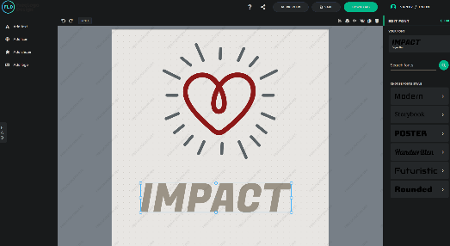It was at this point that I discovered Bootstrap, an HTML framework that eases the tedium of writing a website from scratch. I spent some time learning the basics of Bootstrap and began incorporating some elements of it in my own front-end design. I particularly enjoy the easy to use grid system, and I’m happy to have learned a new and useful tool.

Creating a generic logo on freelogodesign.org

From here I began looking for images and video to use. I searched for open-license artwork and found a website for generating generic logos. I also found several sites that provided open license generic artwork, as well as a corny video that fits well with the overall tone of a volunteer website. My goal here was to use freely available assets that are available under a license that requires only that I provide a simple reference within my own work.

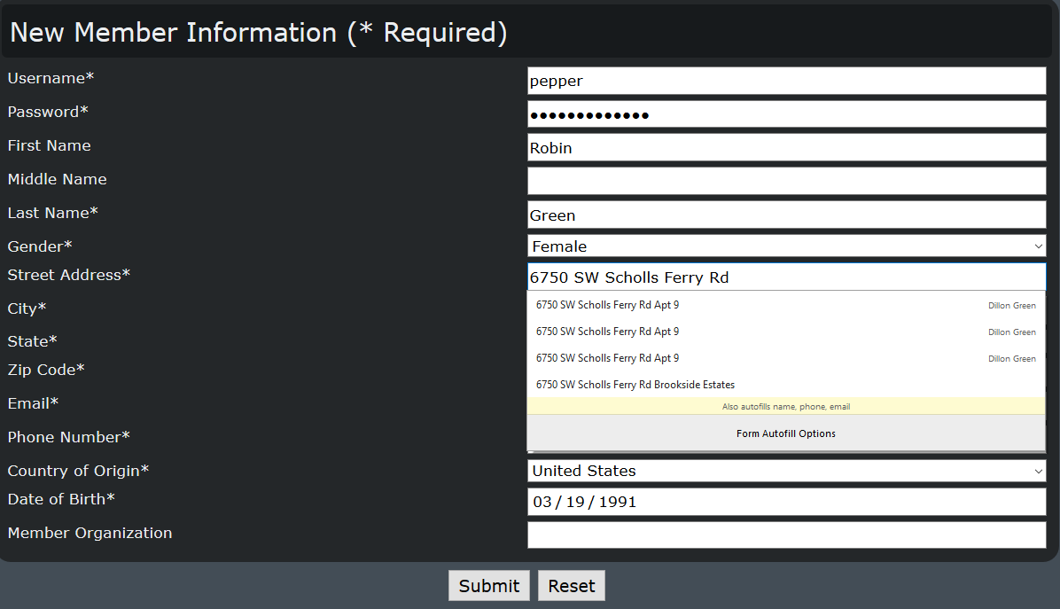Once the index page was looking nice, I created my signup page and began recalling how input works in HTML. This presented the second hurdle: another element of HTML that I needed to recall from last Fall. I spent some time reviewing notes and looking through documentation and before too long I got all required input fields working. I had forgotten that simply specifying an input form’s type makes the element on the page behave accordingly, this was a nice surprise to remember how easy that is.

All inputs working

Finally, the last hurdle was in remembering how in the world regex works, as it has also been a while since I’ve needed to write any regex expressions. I think this took the longest study time of this deliverable, simply due to how arcane some regex syntax looks and feels. I eventually got my input validated for passwords, phone numbers, etc. I also found some selection input options lists on Github for US states and for countries, to eliminate the possibility of users typing these in incorrectly.

The only thing that I was unable to accomplish was translating the geolocation coordinates to a US state. I began looking into using Google’s Maps API but ran out of time to figure it out. However, I do have geolocation working in a minimal fashion on the index page.

User Manual:

The zip file should contain two html files: index.html and signup.html. It also contains the stylesheet for the site, as well as assets for the site, including an svg, a png, and a jpg. Included also are files necessary for the Bootstrap framework.

To open the site, simply open index.html with an up-to-date and modern web browser. Most links on the site do not work and most text is placeholder lorem ipsum text. The video is an embedded Youtube video. At the bottom of the page is a button to find the user’s location. Clicking on the “Detect State” button will ask you to allow location sharing. If you select “allow,” the page will print your longitude and latitude location.

The link “Become a Volunteer” on the navigation bar will bring you to the signup.html page, containing several input fields. Some of these fields restrict the user from continuing forward without properly formatted information. Format hints are given as well as client-side validation using regex patterns. If all information is correctly entered, clicking the “Submit” button will bring the user to a “file not found” page. This means that the form was accepted, it just doesn’t currently do anything.

In conclusion, I’m happy with how my front-end UI has turned out. I enjoyed getting back into HTML and I am happy to learn of new tools such as Bootstrap. My UI looks professional, although admittedly bare-bones, and almost everything has the intended functionality. In future assignments I will try to manage my time better, especially as I begin working with topics that are brand new to me.